Shrinkage correlation: USDJPY and USDCHF
Method 08 / eight-major panel / delta = 0.2 and Ledoit-Wolf / Alpari D1 full available history

Study setup
Logical pair: USDJPY , USDCHF
Broker symbols: USDJPY_i , USDCHF_i
Snapshot: 2026-11-03_majors_alpari_D1
Timeframe: D1
Common eight-major panel window: 1999-01-06 to 2026-11-02 (UTC bar dates)
Panel matched return count n: 7127
Dropped unfinished last bar dated 2026-11-03 UTC after a tick-volume check against the prior complete day.
Fixed shrinkage: delta=0.2, mu=3.9170889e-05 (mean of diag(S))
Ledoit-Wolf estimated delta: 0.0042157642
Panel symbols: EURUSD, GBPUSD, AUDUSD, NZDUSD, USDJPY, USDCHF, USDCAD, EURGBP
Complete matched rows (Excel): USDJPY-USDCHF_Shrinkage_D1.xlsx
Complete matched rows (HTML table): USDJPY-USDCHF_Shrinkage_D1_data.html

Method carried forward
Shrinkage blends the sample covariance matrix S of matched daily log returns of close, ln(close_t / close_t-1), toward a simple target, then converts the shrunk covariance into correlations. Quotes are not inverted. This experiment builds one common calendar across all eight majors, forms S with the unbiased n-1 divisor, then reports two shrinkage specs: fixed delta = 0.2 with mu equal to the average sample variance (mu * I target), and sklearn Ledoit-Wolf with its estimated delta. Pair reports pull rho_ij from those panel matrices. Same-panel Pearson r is a side check only. Shrinkage improves conditioning; it is not a cause, not a lead, and not a trading signal.

Results
pearson_r | rho_02 | rho_LW | rho_02_minus_r | rho_LW_minus_r | delta_LW
0.397789 | 0.320931 | 0.396182 | -0.076858 | -0.001607 | 0.00421576

Conclusion
Over the common 7127-day eight-major panel for USDJPY and USDCHF (broker quote directions unchanged), fixed-delta shrinkage correlation at delta=0.2 is 0.3209 (positive, weak linear link in this sample). Ledoit-Wolf rho is 0.3962 with estimated delta=0.004216. Same-panel Pearson r is 0.3978 (rho_02 minus r = -0.0769; rho_LW minus r = -0.0016). This does not establish cause, lead-lag, or a lasting trading rule.

Charts
Daily closes
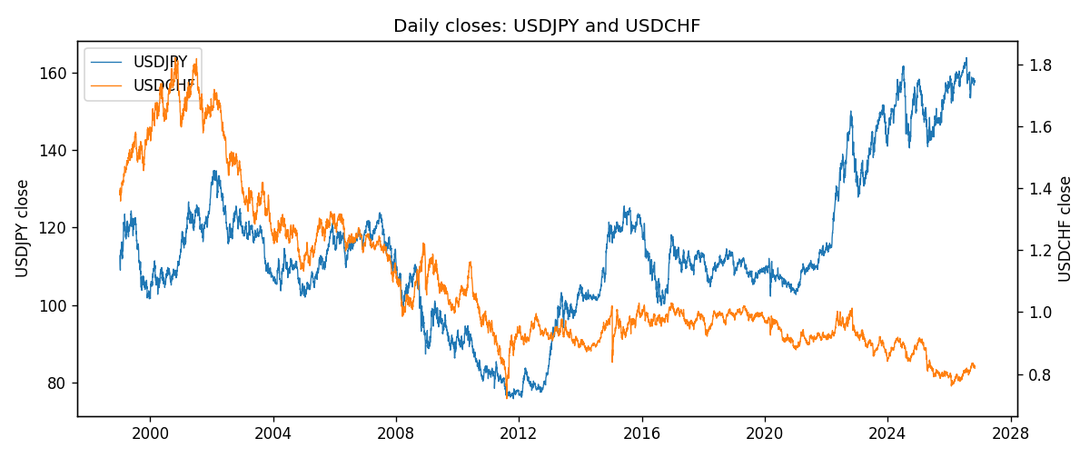
Daily log returns
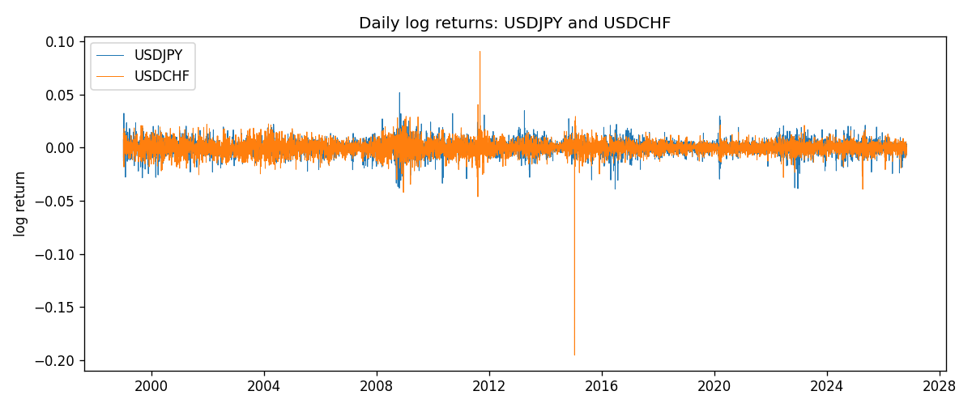
Log-return scatter
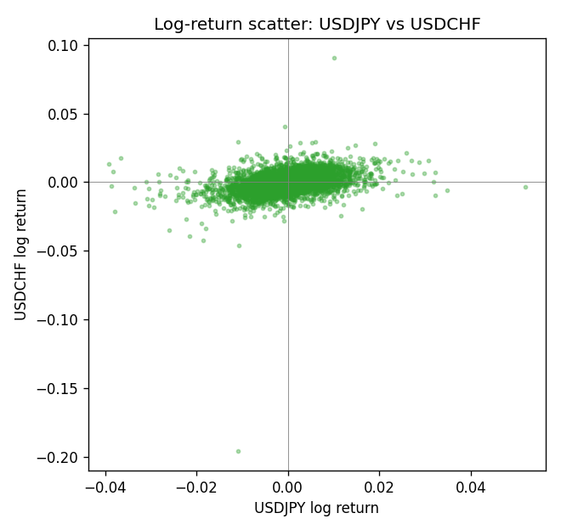

Data report
Every panel row for this pair slice is stored in the sibling Excel workbook named USDJPY-USDCHF_Shrinkage_D1.xlsx. Full-panel covariance and correlation matrices are saved once under outputs/ as CSV files. Embedding all rows as a Word table is impractical at this length; the Word file holds the column list, column summaries, and the first and last 15 matched rows.
Columns: time, USDJPY_open, USDJPY_high, USDJPY_low, USDJPY_close, USDJPY_tick_volume, USDJPY_spread, USDJPY_real_volume, USDJPY_log_return, USDCHF_open, USDCHF_high, USDCHF_low, USDCHF_close, USDCHF_tick_volume, USDCHF_spread, USDCHF_real_volume, USDCHF_log_return
Column summaries (panel rows)
column | count | mean | std | min | 25% | 50% | 75% | max
USDJPY_open | 7127 | 113.80058 | 19.291864 | 75.693 | 104.3005 | 110.961 | 120.7475 | 163.824
USDJPY_high | 7127 | 114.29785 | 19.353625 | 76.001 | 104.822 | 111.42 | 121.29 | 163.978
USDJPY_low | 7127 | 113.2782 | 19.219415 | 75.402 | 103.814 | 110.515 | 120.2 | 163.628
USDJPY_close | 7127 | 113.81424 | 19.307121 | 75.811 | 104.298 | 110.98 | 120.725 | 163.851
USDJPY_tick_volume | 7127 | 107141.8 | 179947.68 | 197 | 10056 | 53577 | 93233 | 1803508
USDJPY_spread | 7127 | 20.095973 | 17.5534 | 0 | 6 | 11 | 30 | 50
USDJPY_real_volume | 7127 | 3.5056645e+10 | 1.6155964e+11 | 0 | 0 | 0 | 0 | 3.8834203e+12
USDJPY_log_return | 7127 | 5.336e-05 | 0.00621278 | -0.03908203 | -0.00319557 | 0.00013026 | 0.00340928 | 0.05184024
USDCHF_open | 7127 | 1.0950724 | 0.25120393 | 0.72022 | 0.92018 | 0.98921 | 1.23375 | 1.8219
USDCHF_high | 7127 | 1.1003422 | 0.25292835 | 0.73305 | 0.924355 | 0.99265 | 1.2388 | 1.8313
USDCHF_low | 7127 | 1.0899719 | 0.24962782 | 0.08565 | 0.91675 | 0.98562 | 1.22815 | 1.8121
USDCHF_close | 7127 | 1.0950652 | 0.25109829 | 0.72025 | 0.92039 | 0.98915 | 1.23375 | 1.8217
USDCHF_tick_volume | 7127 | 74858.54 | 113805.19 | 350 | 12933.5 | 40528 | 70784 | 858589
USDCHF_spread | 7127 | 25.804827 | 24.609722 | 0 | 5 | 16 | 50 | 100
USDCHF_real_volume | 7127 | 2.3477824e+10 | 8.9470976e+10 | 0 | 0 | 0 | 0 | 1.9331921e+12
USDCHF_log_return | 7127 | -7.023e-05 | 0.006591 | -0.19545699 | -0.00334576 | 8.055e-05 | 0.00331687 | 0.09051364
First 15 panel rows (selected columns)
time | USDJPY_close | USDCHF_close | USDJPY_log_return | USDCHF_log_return
1999-01-06 | 112.77 | 1.3912 | 0.0075660159 | 0.013605652
1999-01-07 | 111.33 | 1.3782 | -0.012851583 | -0.0093883841
1999-01-08 | 110.8 | 1.3935 | -0.0047719894 | 0.011040268
1999-01-11 | 109.02 | 1.4009 | -0.016195423 | 0.0052963193
1999-01-12 | 112.6 | 1.3872 | 0.032310364 | -0.0098275602
1999-01-13 | 113.52 | 1.3621 | 0.0081373171 | -0.018259701
1999-01-14 | 113.52 | 1.3588 | 0 | -0.0024256692
1999-01-15 | 114.15 | 1.3834 | 0.0055343401 | 0.01794228
1999-01-18 | 114.16 | 1.379 | 8.7600193e-05 | -0.0031856384
1999-01-19 | 113.52 | 1.3789 | -0.0056219403 | -7.2518946e-05
1999-01-20 | 112.91 | 1.3889 | -0.0053879917 | 0.0072259871
1999-01-21 | 113.87 | 1.3836 | 0.0084664056 | -0.0038232689
1999-01-22 | 114.56 | 1.3834 | 0.0060412564 | -0.0001445609
1999-01-25 | 113.72 | 1.3868 | -0.0073594164 | 0.0024546976
1999-01-26 | 113.86 | 1.3897 | 0.0012303367 | 0.0020889617
Last 15 panel rows (selected columns)
time | USDJPY_close | USDCHF_close | USDJPY_log_return | USDCHF_log_return
2026-10-13 | 158.305 | 0.83244 | -0.0018932826 | -0.0024955621
2026-10-14 | 158.317 | 0.83489 | 7.5800166e-05 | 0.0029388325
2026-10-15 | 158.024 | 0.82676 | -0.0018524319 | -0.0097855323
2026-10-16 | 157.964 | 0.82377 | -0.00037976126 | -0.0036230826
2026-10-19 | 158.517 | 0.82677 | 0.0034946841 | 0.0036351779
2026-10-20 | 158.16 | 0.8246 | -0.0022546642 | -0.0026281224
2026-10-21 | 158.108 | 0.82427 | -0.00032883504 | -0.00040027413
2026-10-22 | 156.755 | 0.82032 | -0.0085942669 | -0.0048036381
2026-10-23 | 156.81 | 0.82497 | 0.00035080446 | 0.005652514
2026-10-26 | 157.458 | 0.82649 | 0.0041238746 | 0.0018407959
2026-10-27 | 157.894 | 0.82865 | 0.0027651658 | 0.0026100526
2026-10-28 | 157.743 | 0.82781 | -0.00095679538 | -0.0010142111
2026-10-29 | 157.683 | 0.82379 | -0.00038043789 | -0.0048680164
2026-10-30 | 157.516 | 0.82438 | -0.0010596481 | 0.00071594559
2026-11-02 | 157.933 | 0.81851 | 0.0026438521 | -0.0071459744

